CLGlo - SEU26 - Audio Modem Project
July-September 2026

Standardisation Meeting #10
Date, Time, Location: | Monday 14 September 2026, 9am, LR5, Cambridge University Engineering Department
Document history | 15/9/2026 Agenda first draft by Jossy

Agenda

- Welcome
- Calls for last minute standards changes
- Give advice for final presentation
- Rehearsal of transmission / receiver plugfest
- Any other business

Review of Confirmed Protocols

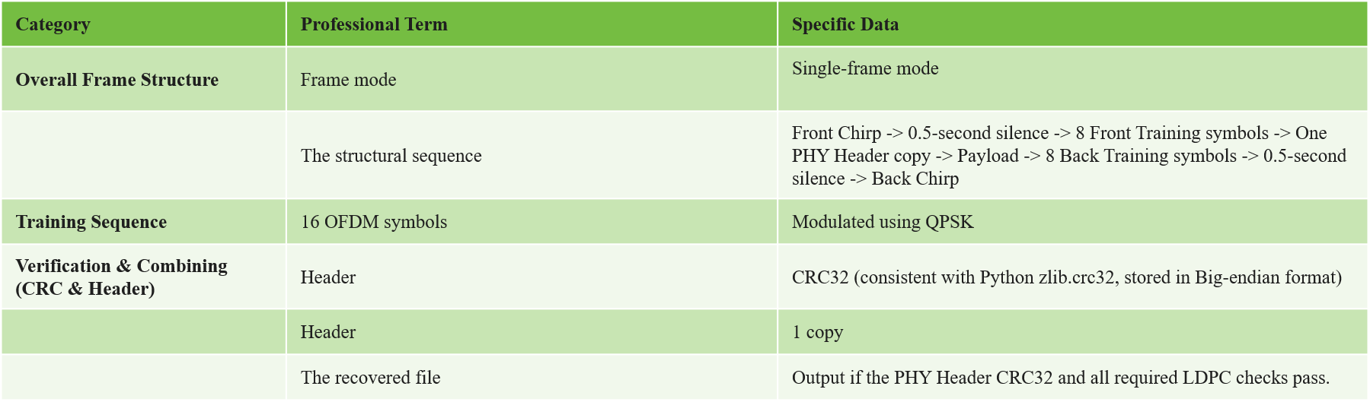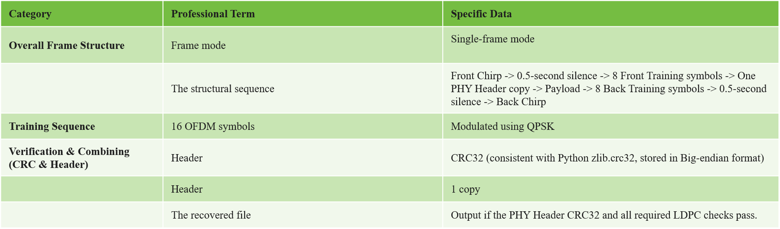

Minutes

Present: | Chair: Jossy  Minutes: Jossy  Attendance/Documentation: -  Delegates  Observers: -  Highlight indicates group chairing the meeting
  Group 1: - Yi Ding | Group 5: -Gerson Liu
  Group 2: - Panpan He | Group 6: -Yi Huang
  Group 3: -Tiancheng Zhang | Group 7: -Hanwen Zhang
  Group 4: -Yuxuan Yuan | Group 8: - Jet Li
Apologies

Meeting commenced at: 9：02

Item No. | Discussion |  | Planned timing (mins) | Action
1 | Welcome  The chair welcomed everyone to the meeting, outlined the agenda and objectives for today's discussion. |  | 3 | Finished at 9:04
2 | Proposals for last minute standard changes  - there is currently no up to date standard document  - The power normalisation for chirp vs. signal has not been agreed in previous meetings. The chair’s recommendation is to keep this out of the standard as every group should be able to decide how to optimally normalise and hence get a better transmitter that more groups will be able to decode. A transmission can hence still be standards-compliant even if the transmission is less successful because the signal isn’t loud enough.  There are no current proposed changes in the standard. However, the 3 standard editors will work on producing a good looking and precise final standards document, which they will present at the start of the final session (about 5 minutes) |  | 10
3 | Advice for final presentation |  | 20
4 |  |  | 50
5 |  |  |  | Finished at 10:02
6 | Any other business (AOB)  In-class transmission testing was carried out. |  | 5 | Finished at 10:05

Meeting concluded at: 10:05

